**:Array and Pointer:**

Name: PAWAN KUMAR MEENA

Roll No:21UFIE2085 Branch : cse

**1.** [**C Program to Calculate Average Using Arrays**](https://www.programiz.com/c-programming/examples/average-arrays)**.**

**Program::**

#include <stdio.h>

int main()

{

int arr[10], sum = 0;

float avg;

for (int i = 0; i < 10; i++)

{

printf("Enter the value of %d array:\n", i + 1);

scanf("%d", &arr[i]);

}

for (int i = 0; i < 10; i++)

{

sum = sum + arr[i];

}

printf("Sum of the array = %d\n",sum);

avg = sum / 10.0;

printf("Average of arrys = %f\n", avg);

return 0;

}

**Output::**

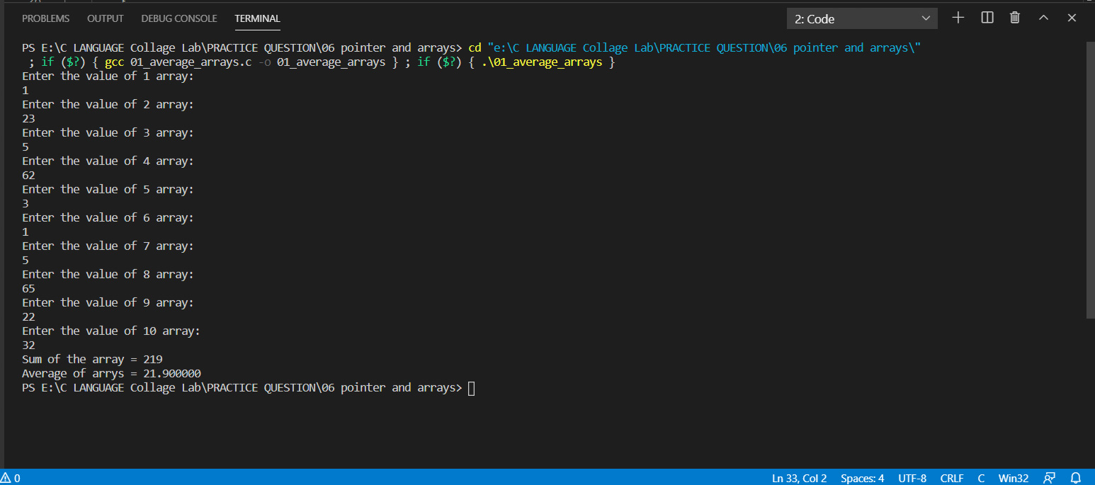

**2.** [**C Program to Find Largest Element of an Array**](https://www.programiz.com/c-programming/examples/array-largest-element)**.**

**Program::**

#include<stdio.h>

int main ()

{

int array[10],larg=0;

for (int i = 0; i < 10; i++)

{

printf("Enter the %d elements of the array:\n",i+1);

scanf("%d",&array[i]);

}

for (int i = 0; i < 10; i++)

{

if (array[i]>larg)

{

larg=array[i];

}

}

Printf("Largest number of the array is = %d\n",larg);

return 0;

}

**Output::**

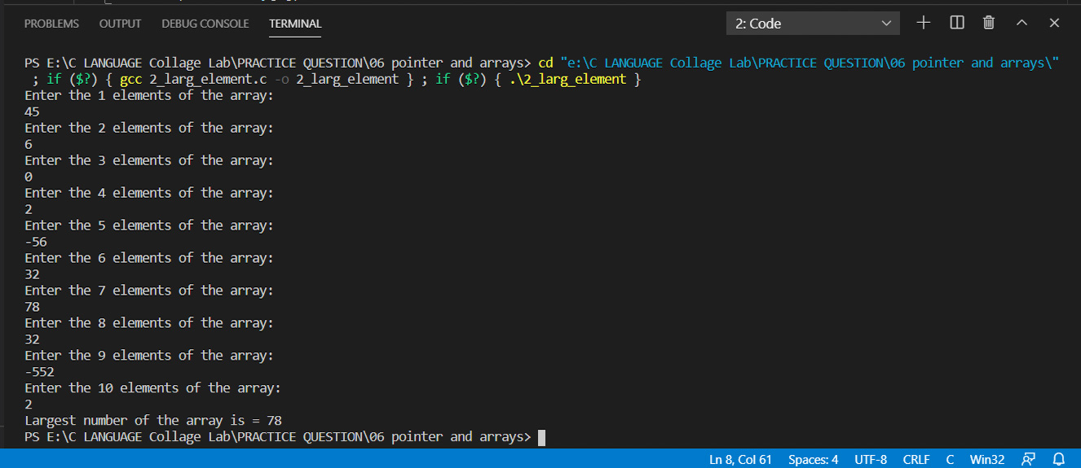

**3. Write a program to count no. of positive numbers, negative numbers and zeros in the array.**

**Program::**

#include <stdio.h>

int main()

{

int array[10], nop = 0, non = 0, noz = 0;

for (int i = 0; i < 10; i++)

{ printf("Enter the %d elements of the array:\n", i + 1);

scanf("%d", &array[i]);

}

for (int i = 0; i < 10; i++)

{

if (array[i] > 0)

{

nop++;

}

else if (array[i] < 0)

{

non++;

}

else

{ noz++;

}

}

printf("Nomber of positive elements = %d\n", nop);

printf("Nomber of negative elements = %d\n", non);

printf("Nomber of zero elements = %d\n", noz);

return 0;

}

**Output::**

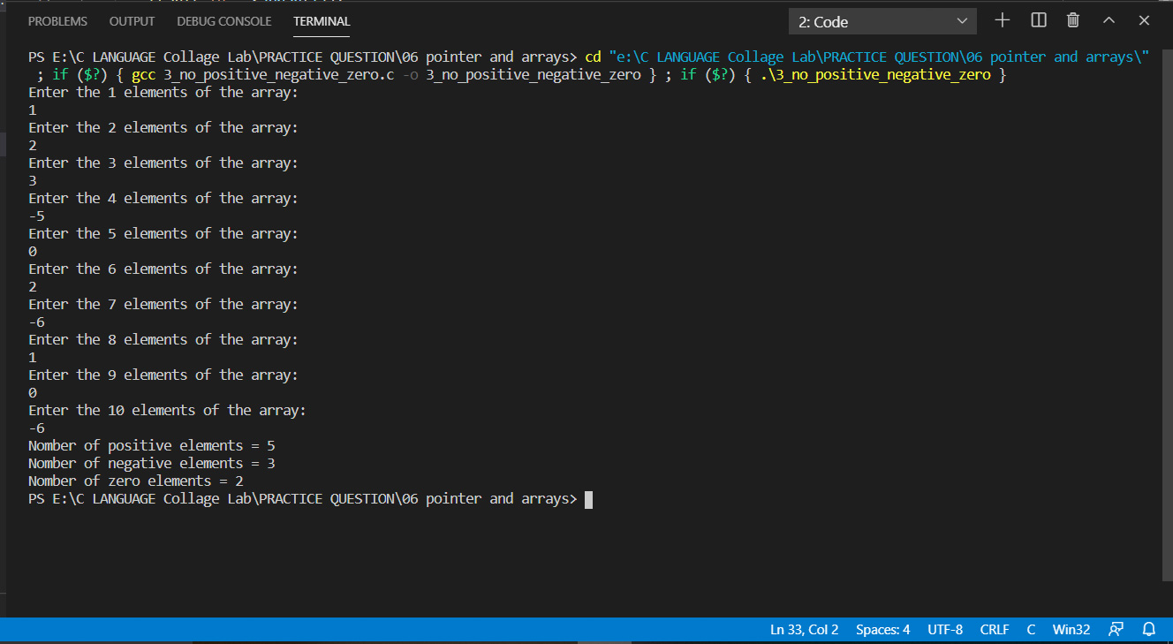

**4. Write a program to search the given element by using linear search.**

**Program::**

#include<stdio.h>

int main (){

int array[] = {1,4,5,2,8,-7,0,23,14,-3,6,-2,12,4,86};

int num;

printf("Enter the number which you want to search::\n");

scanf("%d",&num);

int i;

for (i = 0; i < 15; i++)

{

if (num= =array[i])

{

printf("Number %d is avalible in the array::\n",num);

break;

}

}

if (num!=array[i])

{

printf("Number %d is not avalible in the array::\n",num);

}

return 0;

}

**Output::**

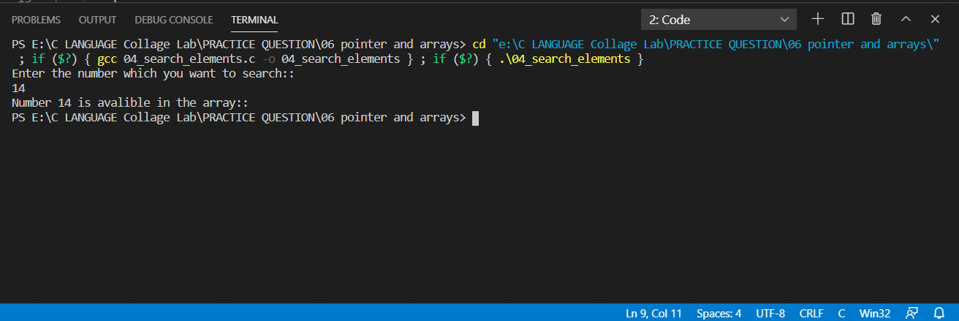

**5.** [**C Program to Add Two Matrix Using Multi-dimensional Arrays**](https://www.programiz.com/c-programming/examples/add-matrix)**.**

**Program::**

#include <stdio.h>

int main()

{

int mat1[5][5], mat2[5][5], sum[5][5];

int c, r;

printf("Enter the number of rows and column of the metrix::\n");

scanf("%d%d", &r, &c);

printf("::Enter the elements of the first metrix::\n");

for (int i = 0; i < r; i++)

{

for (int j = 0; j < c; j++)

{

scanf("%d", &mat1[i][j]);

}

}

printf("::Enter the elements of the second metrix::\n");

for (int i = 0; i < r; i++)

{

for (int j = 0; j < c; j++)

{

scanf("%d", &mat2[i][j]);

}

}

printf("\n::Elements of the first metrix::\n");

for (int i = 0; i < r; i++)

{

for (int j = 0; j < c; j++)

{

printf("%d ", mat1[i][j]);

}

printf("\n");

}

printf("\n::Elements of the second metrix::\n");

for (int i = 0; i < r; i++)

{

for (int j = 0; j < c; j++)

{

printf("%d ", mat2[i][j]);

}

printf("\n");

}

printf("\n\n::Sum of matrix first and metrix second::\n");

for (int i = 0; i < r; i++)

{

for (int j = 0; j < c; j++)

{

sum[i][j] = mat1[i][j] + mat2[i][j];

printf("%d ", sum[i][j]);

}

printf("\n");

}

return 0;

}

**Output::**

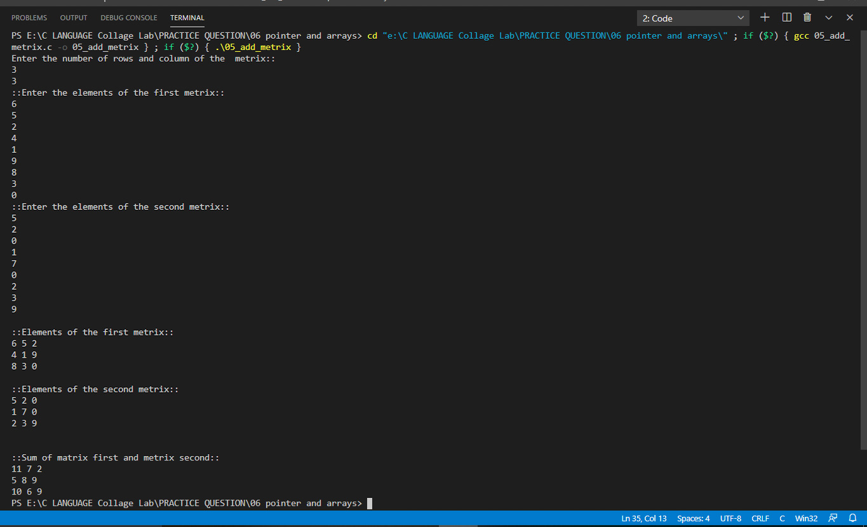

**6.** [**C Program to Multiply to Matrix Using Multi-dimensional Arrays**](https://www.programiz.com/c-programming/examples/matrix-multiplication)**.**

**Program::**

#include <stdio.h>

int main()

{

int mat1[5][5], mat2[5][5], mult[5][5];

int c1, r1, c2, r2;

printf("Enter the number of rows and column of first metrix::\n");

scanf("%d%d", &r1, &c1);

printf("Enter the number of rows and column of second metrix::\n");

scanf("%d%d", &r2, &c2);

if (r1 != c2 || c1 != r2)

{

printf("Error! Row of the first metrix not equal to column of second metrix \nOr Column of first metrix is not equal to row of second metrix");

printf("Please Enter valid number rows and column::\n");

printf("Enter the number of rows and column of first metrix::\n");

scanf("%d%d", &r1, &c1);

printf("Enter the number of rows and column of second metrix::\n");

scanf("%d%d", &r2, &c2);

}

printf("\n::Enter the elements of the first metrix::\n");

for (int i = 0; i < r1; i++)

{

for (int j = 0; j < c1; j++)

{

scanf("%d", &mat1[i][j]);

}

}

printf("\n::Enter the elements of the second metrix::\n");

for (int i = 0; i < r2; i++)

{

for (int j = 0; j < c2; j++)

{

scanf("%d", &mat2[i][j]);

}

}

printf("\n::Elements of the first metrix::\n");

for (int i = 0; i < r1; i++)

{

for (int j = 0; j < c1; j++)

{

printf("%d ", mat1[i][j]);

}

printf("\n");

}

printf("\n::Elements of the second metrix::\n");

for (int i = 0; i < r2; i++)

{

for (int j = 0; j < c2; j++)

{

printf("%d ", mat2[i][j]);

}

printf("\n");

}

// r1==c2 and c1==r2

printf("\n\n::Multiplation of first metrix and second metrix::\n");

for (int k = 0; k < r1; k++)

{

for (int i = 0; i < c2; i++)

{

mult[k][i] = 0;

for (int j = 0; j < c1; j++)

{

mult[k][i] = mult[k][i] + mat1[k][j] * mat2[j][i];

}

printf("%d\t", mult[k][i]);

}

printf("\n");

}

return 0;

}

**Output::**

